Graph Database

As your selected company grows, you are asked to consider migrating its current relational database (which you previously designed and implemented in Assignment 1) to a NoSQL database that provides a better scalability in Big Data environment. Specifically, the company has nominated Neo4j as the new database management platform

**Part I. Graph Database Modelling**

Convert your existing EER into a graph model and produce a simple drawing of its basic graph structure

Revised EER

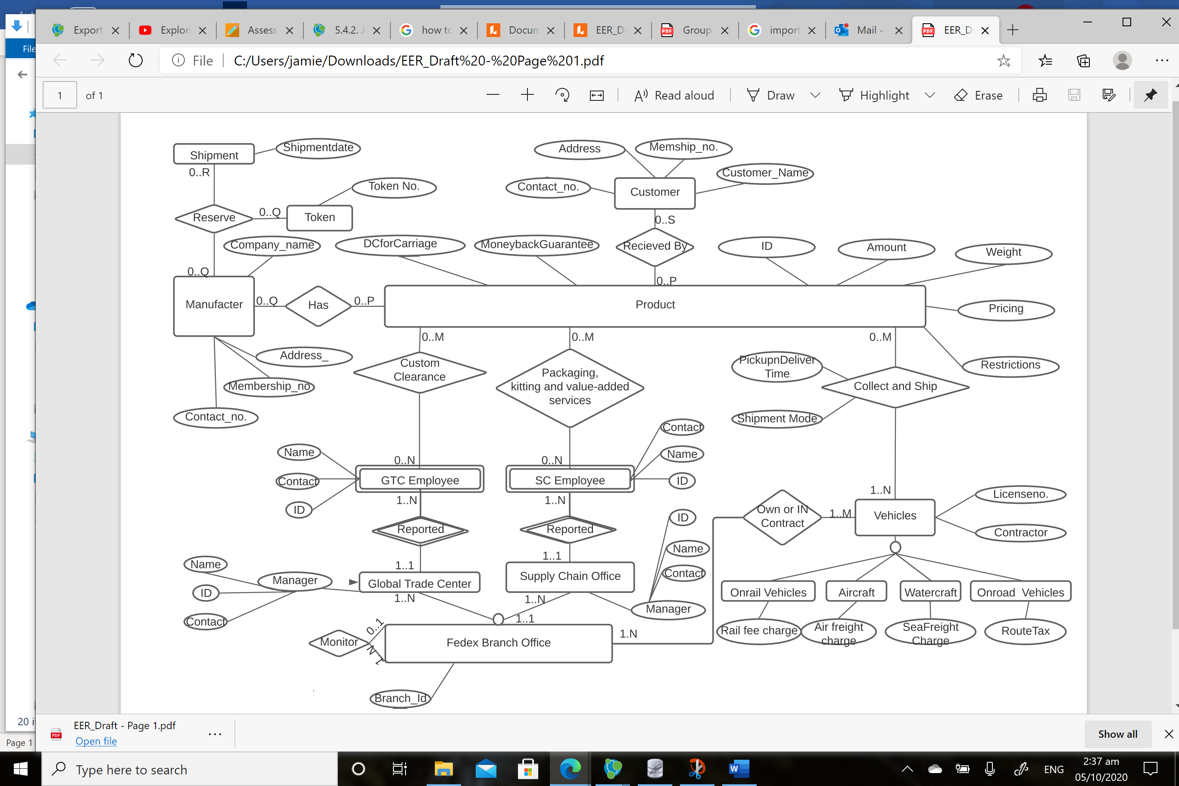



Converted Graph Model by call db.schema.visualization command

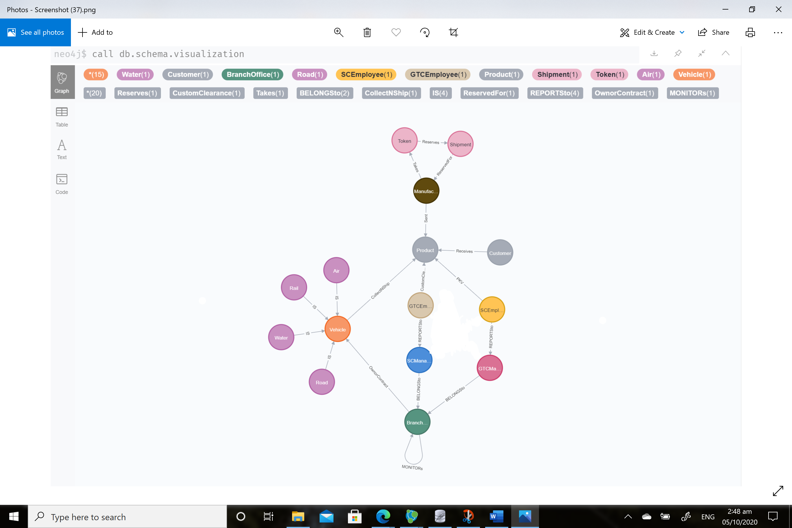

Graph Model

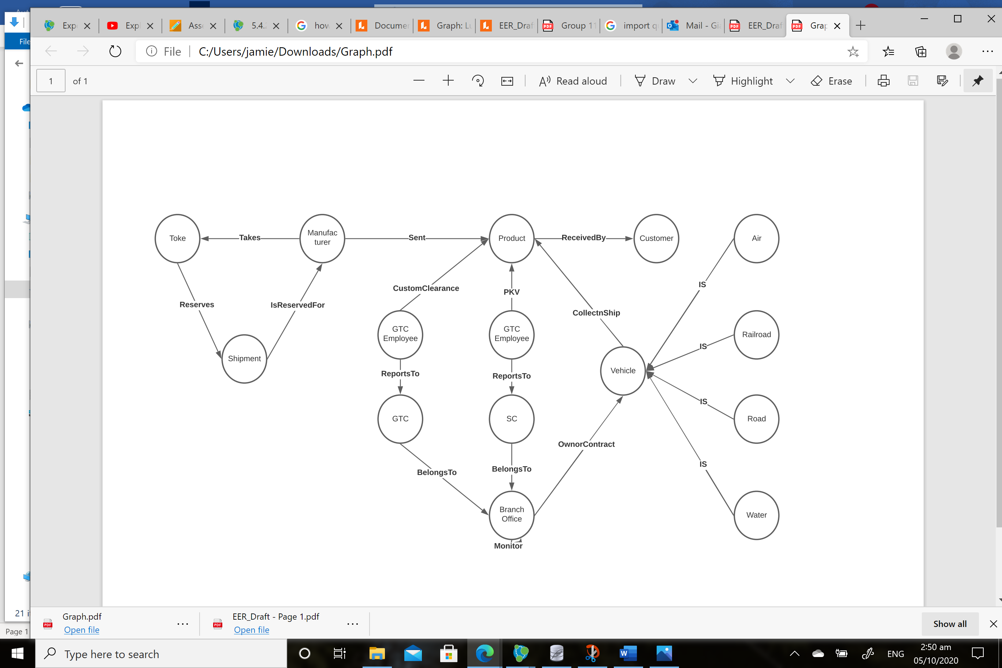

**Part II. Graph Database Implementation**

Based on the produced graph model, write Cypher scripts to fully migrate the relational database into a Neo4j database. These include Cypher scripts for:

• Importing relational data from .csv files into Neo4j database (including scripts for creating nodes and relationships)

• Creating index

Cypher scripts are available in a single file called import.cypher

**Part III. Cypher Query**

Write three Cypher query scripts to produce results equivalent to the three SQL queries you produced in Assignment 1. Cypher scripts are available in a single file called queries.cypher

Queries from Assignment 1:  
1. Find the available Branch for FedEx Freight to start the shipment. Note that the two offices (Global Trade Center and Supply Chain Office) have to be in the same branch to process your order.

2. Retrieve a list of customer names that have their order delivered from flight no. V3274T .

3. Use nested subquery to extract customer’s information (name & contact) receive product under Economy shipment mode (Boolean-0).

4.Retrieve a list for service update request using EXIST command to sort out those products that have dangerous goods restriction, no moneyback guarantee, and declared-value for carriage greater than $5000.

Using Neo4J Functions:

5. Use node() function to find out the product allocation for custom clearance.

6. Find the list of manufacturers that has reserved shipments following the token order.

7. Find out the Manufacturer that did not send any products.

8. Export a list of Priority Shipping products using EXIST().

9. Utilize count() function to determine the amount of products that are shipped by air.

Graph Similarity Algorithm  
10. Use Jaccard algorithm to find the similarity of GTC Employees and SC Employees’ product handling at the same branch (Adrian Edwards, Sarah Marshal, Sarah Mitchel).